**Software Requirements Specification**

**Version <Version 1>**

**<ABC FAST SOCIETY>**

**Team <Group 9>**

|  |  |  |
| --- | --- | --- |
| Member Name | Member Roll # | Primary Responsibility |
| M.Zubair | L15-4034 | Use Case and analysis |
| T Taimoor Mirza | T L14-4520 | Non Functional and other re requirement writing |
| Muhammad Fahad | L15-4379 | Basic introduction of this  Project writing |
| **L1** M. Jamal Butt **L** | L15-4255 | Use Case and analysis |
| Abdul Rafey Tahir | L14-4014 | Basic introduction of this  Project writing |
|  |  |  |

**Table of Contents**

Table of Contents.......................................................................................................................... ii

Revision History............................................................................................................................ iii

1. Introduction.............................................................................................................................. 2

1.1 Product............................................................................................................................. 2

1.2 Scope............................................................................................................................... 2

1.3 Business Goals................................................................................................................ 4

1.4 Document Conventions.................................................................................................... 4

1.5 References....................................................................................................................... 4

2. Overall Description........................................................................................................... 4

2.1 Product Features.............................................................................................................. 4

2.2 User Classes and Characteristics..................................................................................... 4

2.3 Operating Environment..................................................................................................... 5

2.4 Design and Implementation Constraints........................................................................... 5

2.5 Assumptions and Dependencies...................................................................................... 5

3. Functional Requirements...................................................................................................5

3.1 to 3.20 Use-Case 1 to 20........................................................................................... 5 - 26

4. Nonfunctional Requirements.................................................................................................. 26

4.1 Performance………………............................................................................................. 26

4.2 Security………………..................................................................................................... 26

4.3 Usability………………..................................................................................................... 26

4.4 Compatibility…....……..................................................................................................... 26

5. Other Requirements........................................................................................................ 27

Appendix A:Glossary...................................................................................................................27

Appendix B: AnalysisModels..................................................................................................27-34

Appendix C: Design Models......................................................................................................34

Appendix D: Screenshots...........................................................................................................34

Appendix E: Test Cases..............................................................................................................35

Appendix F: IV & V Report.........................................................................................................36

Appendix G: Risk Report............................................................................................................ 36

Appendix H: Activity Timesheet.................................................................................................. 37

Appendix I: Updated Project Plan............................................................................................... 37

Revision History

|  |  |  |  |
| --- | --- | --- | --- |
| **Name(s)** | **Date** | **Reason(s) For Change(s)** | **Version** |
|  |  |  |  |
|  |  |  |  |

# 

# **1. Introduction**

## **1.1 Product**

This project is about creating a website for ABC Society of Fast Nuces. In the website, a society can publish news, events, team hierarchy and book bank. The purpose of this project is to develop a website that can help students of FAST to find information about any ABC Society. Its features will enable students to see information about news, events etc. of the society. Societies usually promote themselves by using social networking websites. It is very hard to maintain information in a proper format on these sites. Students have to scroll and search a lot to find relevant information about the society. This website is a solution to all these issues. A user will be able to find appropriate and necessary information in just a few seconds according to his/her interest.

## **1.2 Scope**

**Admin Students can Create**, **Edit and Delete Information about**

· News of the society

· Events of the society.

· Team and faculty members of the society.

· Book bank of the society.

**Non Admin Students can View Information About**

· News of the society

· Events of the society

· Team and faculty of the society

· Books in the book bank of the society

. Contact Information of the society

## **1.3 Business Goal**

The objective of this website is to facilitate students and society. With the help of this website, people can have proper interaction with the society. Society can beforehand post different announcements, while students can easily view them.

## **1.4 Document Conventions**

No special conventions were followed. But we only want to mention that all diagrams were made using StarUml software.  
  
**1.5 References**

This is the link of software of star uml.  
  
http://staruml.io/

# **2. Overall Description**

## **2.1 Product Features**

· <Summarize the major features the product contains or the significant functions that it performs or lets the user perform. Details will be provided in Section 3, so only a high level summary is needed here. Organize the functions to make them understandable to any reader of the SRS.>

## **2.2 User Classes and Characteristics**

· <Identify the various user classes that you anticipate will use this product. User classes may be differentiated based on frequency of use, subset of product functions used, technical expertise, security or privilege levels, educational level, or experience. Describe the pertinent characteristics of each user class. Certain requirements may pertain only to certain user classes. Distinguish the favored user classes from those who are less important to satisfy.>

## **2.3 Operating Environment**

· <Describe the environment in which the software will operate, including the hardware platform, operating system and versions, and any other software components or applications with which it must peacefully coexist.>

## **2.4 Design and Implementation Constraints**

· <Describe any items or issues that will limit the options available to the developers. These might include: corporate or regulatory policies; hardware limitations (timing requirements, memory requirements); interfaces to other applications; specific technologies, tools, and databases to be used; parallel operations; language requirements; communications protocols; security considerations; design conventions or programming standards (for example, if the customer’s organization will be responsible for maintaining the delivered software).>

## **2.5 Assumptions and Dependencies**

· <List any assumed factors (as opposed to known facts) that could affect the requirements stated in the SRS. These could include third-party or commercial components that you plan to use, issues around the development or operating environment, or constraints. The project could be affected if these assumptions are incorrect, are not shared, or change. Also identify any dependencies the project has on external factors, such as software components that you intend to reuse from another project, unless they are already documented elsewhere (for example, in the vision and scope document or the project plan).>

# **3. Functional Requirements**

· <All functional requirements are expressed as use-cases. Fill out the following template for each use-case. Don’t really say “Use-Case 1.” State the use-case name in just a few words e.g. “Withdraw Cash from ATM”. A use-case may have multiple alternate courses of action.>

## **3.1 Use-Case 1**

|  |  |  |  |
| --- | --- | --- | --- |
| **Identifier** | | UC-1 | |
| **Purpose** | | Adding society executive | |
| **Priority** | | Medium | |
| **Actors** | | Admin | |
| **Pre-conditions** | | CRUD team page is currently online. Admin knows about team member details. | |
| **Post-conditions** | | An executive team member will be added. | |
| **Typical Course of Action** | | | |
| **S#** | **Actor Action** | | **System Response** |
| **1** | Admin will click on the, ‘Add Button’. | |  |
| **2** |  | | A form will be available/visible to the admin. |
| **3** | Admin will enter information about the society member. | |  |
| **4** | Admin will click on the Submit button. | |  |
| **5** |  | | Notification saying, “Person added successfully” will be displayed. |
| **6** |  | | Redirects back to the CRUD team page. |
| **Added person already exists.** | | | |
| **S#** | **Actor Action** | | **System Response** |
| **5** |  | | Notification saying, “Person cannot be added. Entity already exists.” will be displayed. |
| **6** |  | | Redirects back to the CRUD team page. |
|  |  |  |  |

Table 1: UC-1

## **3.2 Use-Case 2**

|  |  |  |  |
| --- | --- | --- | --- |
| **Identifier** | | UC-2 | |
| **Purpose** | | Editing society executive information. | |
| **Priority** | | High | |
| **Actors** | | Admin | |
| **Pre-conditions** | | CRUD team page is currently online. Admin knows about team member details. | |
| **Post-conditions** | | An executive team member information will be updated. | |
| **Typical Course of Action** | | | |
| **S#** | **Actor Action** | | **System Response** |
| **1** | Admin will click on the, ‘Edit Button’. | |  |
| **2** |  | | A form will be available/visible to the admin. |
| **3** |  | | Prior information of the team executive will be displayed inside the form. |
| **4** | Admin will edit information about the society member. | |  |
| **5** | Admin will click on the Submit button. | |  |
| **6** |  | | Notification saying, “Person edited successfully” will be displayed. |
| **7** |  | | Redirects back to the CRUD team page. |
|  |  |  |  |

Table 2: UC-2

## **3.3 Use-Case 3**

|  |  |  |  |
| --- | --- | --- | --- |
| **Identifier** | | UC-3 | |
| **Purpose** | | Deleting society executive. | |
| **Priority** | | High | |
| **Actors** | | Admin | |
| **Pre-conditions** | | CRUD team page is currently online. Admin knows about team member details. | |
| **Post-conditions** | | An executive team member will be deleted. | |
| **Typical Course of Action** | | | |
| **S#** | **Actor Action** | | **System Response** |
| **1** | Admin will click on the, ‘Delete Button’. | |  |
| **2** |  | | Notification saying, “Person deleted successfully” will be displayed. |
| **3** | Admin will click ‘Ok’ on the prompt to continue with the deletion | |  |
| **4** |  | | Redirects back to the CRUD team page. |
|  |  |  |  |

Table 3: UC-3

## **3.4 Use-Case 4**

|  |  |  |  |
| --- | --- | --- | --- |
| **Identifier** | | UC-4 | |
| **Purpose** | | Adding society faculty advisor | |
| **Priority** | | Medium | |
| **Actors** | | Admin | |
| **Pre-conditions** | | CRUD faculty page is currently online. Admin knows about faculty advisor details. | |
| **Post-conditions** | | A faculty member will be added. | |
| **Typical Course of Action** | | | |
| **S#** | **Actor Action** | | **System Response** |
| **1** | Admin will click on the, ‘Add Button’. | |  |
| **2** |  | | A form will be available/visible to the admin. |
| **3** | Admin will enter information about the faculty advisor. | |  |
| **4** | Admin will click on the Submit button. | |  |
| **5** |  | | Notification saying, “Person added successfully” will be displayed. |
| **6** |  | | Redirects back to the CRUD faculty page. |
| **Added person already exists.** | | | |
| **S#** | **Actor Action** | | **System Response** |
| **5** |  | | Notification saying, “Person cannot be added. Entity already exists.” will be displayed. |
| **6** |  | | Redirects back to the CRUD faculty page. |
|  |  |  |  |

Table 4: UC-4

## **3.5 Use-Case 5**

|  |  |  |  |
| --- | --- | --- | --- |
| **Identifier** | | UC-5 | |
| **Purpose** | | Editing faculty advisor information. | |
| **Priority** | | High | |
| **Actors** | | Admin | |
| **Pre-conditions** | | CRUD faculty page is currently online. Admin knows about the faculty advisor. | |
| **Post-conditions** | | A faculty member information will be updated. | |
| **Typical Course of Action** | | | |
| **S#** | **Actor Action** | | **System Response** |
| **1** | Admin will click on the, ‘Edit Button’. | |  |
| **2** |  | | A form will be available/visible to the admin. |
| **3** |  | | Prior information of the faculty advisor will be displayed inside the form. |
| **4** | Admin will edit information about the society member. | |  |
| **5** | Admin will click on the Submit button. | |  |
| **6** |  | | Notification saying, “Person edited successfully” will be displayed. |
| **7** |  | | Redirects back to the CRUD team page. |
|  |  |  |  |

Table 5: UC-5

## **3.6 Use-Case 6**

|  |  |  |  |
| --- | --- | --- | --- |
| **Identifier** | | UC-6 | |
| **Purpose** | | Deleting society advisor. | |
| **Priority** | | High | |
| **Actors** | | Admin | |
| **Pre-conditions** | | CRUD faculty page is currently online. Admin knows about the faculty member details. | |
| **Post-conditions** | | An faculty advisor will be deleted. | |
| **Typical Course of Action** | | | |
| **S#** | **Actor Action** | | **System Response** |
| **1** | Admin will click on the, ‘Delete Button’. | |  |
| **2** |  | | Notification saying, “Person deleted successfully” will be displayed. |
| **3** | Admin will click ‘Ok’ on the prompt to continue with the deletion | |  |
| **4** |  | | Redirects back to the CRUD faculty page. |
|  |  |  |  |

Table 6: UC-6

**3.7 Use-Case 7**

|  |  |  |  |
| --- | --- | --- | --- |
| **Identifier** | | UC-7 | |
| **Purpose** | | Adding society news information | |
| **Priority** | | Medium | |
| **Actors** | | Admin | |
| **Pre-conditions** | | CRUD news page is currently online. Admin knows about news details. | |
| **Post-conditions** | | A news information will be added. | |
| **Typical Course of Action** | | | |
| **S#** | **Actor Action** | | **System Response** |
| **1** | Admin will click on the, ‘Add Button’. | |  |
| **2** |  | | A form will be available/visible to the admin. |
| **3** | Admin will enter information about news. | |  |
| **4** | Admin will click on the Submit button. | |  |
| **5** |  | | Notification saying, “news added successfully” will be displayed. |
| **6** |  | | Redirects back to the CRUD news page. |
|  |  |  |  |

Table 7: UC-7

## **3.8 Use-Case 8**

|  |  |  |  |
| --- | --- | --- | --- |
| **Identifier** | | UC-8 | |
| **Purpose** | | Editing news information. | |
| **Priority** | | High | |
| **Actors** | | Admin | |
| **Pre-conditions** | | CRUD news page is currently online. Admin knows about the news details. | |
| **Post-conditions** | | A news information will be updated. | |
| **Typical Course of Action** | | | |
| **S#** | **Actor Action** | | **System Response** |
| **1** | Admin will click on the, ‘Edit Button’. | |  |
| **2** |  | | A form will be available/visible to the admin. |
| **3** |  | | Prior information of the news advisor will be displayed inside the form. |
| **4** | Admin will edit information about the society member. | |  |
| **5** | Admin will click on the Submit button. | |  |
| **6** |  | | Notification saying, “News edited successfully” will be displayed. |
| **7** |  | | Redirects back to the CRUD news page. |
|  |  |  |  |

Table 8: UC-8

## 

## **3.9 Use-Case 9**

|  |  |  |  |
| --- | --- | --- | --- |
| **Identifier** | | UC-9 | |
| **Purpose** | | Deleting society news. | |
| **Priority** | | High | |
| **Actors** | | Admin | |
| **Pre-conditions** | | CRUD news page is currently online. Admin knows about news details. | |
| **Post-conditions** | | A society news will be deleted. | |
| **Typical Course of Action** | | | |
| **S#** | **Actor Action** | | **System Response** |
| **1** | Admin will click on the, ‘Delete Button’. | |  |
| **2** |  | | Notification saying, “News deleted successfully” will be displayed. |
| **3** | Admin will click ‘Ok’ on the prompt to continue with the deletion | |  |
| **4** |  | | Redirects back to the CRUD News page. |
|  |  |  |  |

Table 9: UC-9  
  
**3.10 Use-Case 10**

|  |  |  |  |
| --- | --- | --- | --- |
| **Identifier** | | UC-10 | |
| **Purpose** | | Adding society event information | |
| **Priority** | | Medium | |
| **Actors** | | Admin | |
| **Pre-conditions** | | CRUD event page is currently online. Admin knows about event details. | |
| **Post-conditions** | | A event information will be added. | |
| **Typical Course of Action** | | | |
| **S#** | **Actor Action** | | **System Response** |
| **1** | Admin will click on the, ‘Add Button’. | |  |
| **2** |  | | A form will be available/visible to the admin. |
| **3** | Admin will enter information about event. | |  |
| **4** | Admin will click on the Submit button. | |  |
| **5** |  | | Notification saying, “event added successfully” will be displayed. |
| **6** |  | | Redirects back to the CRUD event page. |
| **Added Event already exists.** | | | |
| **S#** | **Actor Action** | | **System Response** |
| **5** |  | | Notification saying, “Event cannot be added. Entity already exists.” will be displayed. |
| **6** |  | | Redirects back to the CRUD event page. |
|  |  |  |  |

Table 10: UC-10

## **3.11 Use-Case 11**

|  |  |  |  |
| --- | --- | --- | --- |
| **Identifier** | | UC-11 | |
| **Purpose** | | Editing event information. | |
| **Priority** | | High | |
| **Actors** | | Admin | |
| **Pre-conditions** | | CRUD event page is currently online. Admin knows about the event details. | |
| **Post-conditions** | | A event information will be updated. | |
| **Typical Course of Action** | | | |
| **S#** | **Actor Action** | | **System Response** |
| **1** | Admin will click on the, ‘Edit Button’. | |  |
| **2** |  | | A form will be available/visible to the admin. |
| **3** |  | | Prior information of the event advisor will be displayed inside the form. |
| **4** | Admin will edit information about the society member. | |  |
| **5** | Admin will click on the Submit button. | |  |
| **6** |  | | Notification saying, “Event edited successfully” will be displayed. |
| **7** |  | | Redirects back to the CRUD event page. |
|  |  |  |  |

Table 11: UC-11

## **3.12 Use-Case 12**

|  |  |  |  |
| --- | --- | --- | --- |
| **Identifier** | | UC-12 | |
| **Purpose** | | Deleting society event. | |
| **Priority** | | High | |
| **Actors** | | Admin | |
| **Pre-conditions** | | CRUD event page is currently online. Admin knows about event details. | |
| **Post-conditions** | | A society event will be deleted. | |
| **Typical Course of Action** | | | |
| **S#** | **Actor Action** | | **System Response** |
| **1** | Admin will click on the, ‘Delete Button’. | |  |
| **2** |  | | Notification saying, “Event deleted successfully” will be displayed. |
| **3** | Admin will click ‘Ok’ on the prompt to continue with the deletion | |  |
| **4** |  | | Redirects back to the CRUD Event page. |
|  |  |  |  |

Table 12: UC-12

## **3.13 Use-Case 13**

|  |  |  |  |
| --- | --- | --- | --- |
| **Identifier** | | UC-13 | |
| **Purpose** | | Adding information about book in society book bank | |
| **Priority** | | Medium | |
| **Actors** | | Admin | |
| **Pre-conditions** | | CRUD book page is currently online. Admin knows about book details. | |
| **Post-conditions** | | A book information will be added. | |
| **Typical Course of Action** | | | |
| **S#** | **Actor Action** | | **System Response** |
| **1** | Admin will click on the, ‘Add Button’. | |  |
| **2** |  | | A form will be available/visible to the admin. |
| **3** | Admin will enter information about book. | |  |
| **4** | Admin will click on the Submit button. | |  |
| **5** |  | | Notification saying, “book added successfully” will be displayed. |
| **6** |  | | Redirects back to the CRUD book page. |
|  |  |  |  |

Table 13: UC-13

## **3.14 Use-Case 14**

|  |  |  |  |
| --- | --- | --- | --- |
| **Identifier** | | UC-14 | |
| **Purpose** | | Editing book information. | |
| **Priority** | | High | |
| **Actors** | | Admin | |
| **Pre-conditions** | | CRUD book page is currently online. Admin knows about the book details. | |
| **Post-conditions** | | A book information will be updated. | |
| **Typical Course of Action** | | | |
| **S#** | **Actor Action** | | **System Response** |
| **1** | Admin will click on the, ‘Edit Button’. | |  |
| **2** |  | | A form will be available/visible to the admin. |
| **3** |  | | Prior information of the book advisor will be displayed inside the form. |
| **4** | Admin will edit information about the society member. | |  |
| **5** | Admin will click on the Submit button. | |  |
| **6** |  | | Notification saying, “Book edited successfully” will be displayed. |
| **7** |  | | Redirects back to the CRUD book page. |
|  |  |  |  |

Table 14: UC-14

## **3.15 Use-Case 15**

|  |  |  |  |
| --- | --- | --- | --- |
| **Identifier** | | UC-15 | |
| **Purpose** | | Deleting society book. | |
| **Priority** | | High | |
| **Actors** | | Admin | |
| **Pre-conditions** | | CRUD book page is currently online. Admin knows about book details. | |
| **Post-conditions** | | A society book will be deleted. | |
| **Typical Course of Action** | | | |
| **S#** | **Actor Action** | | **System Response** |
| **1** | Admin will click on the, ‘Delete Button’. | |  |
| **2** |  | | Notification saying, “Book deleted successfully” will be displayed. |
| **3** | Admin will click ‘Ok’ on the prompt to continue with the deletion | |  |
| **4** |  | | Redirects back to the CRUD Book page. |
|  |  |  |  |

Table 15: UC-15  
  
**3.16 Use-Case 16**

|  |  |  |  |
| --- | --- | --- | --- |
| **Identifier** | | UC-16 | |
| **Purpose** | | Login of Admin | |
| **Priority** | | High | |
| **Actors** | | Admin | |
| **Pre-conditions** | | Login Page is open. | |
| **Post-conditions** | | Admin will have access to admin Panel. | |
| **Typical Course of Action** | | | |
| **S#** | **Actor Action** | | **System Response** |
| **1** | Admin will enter ID. | |  |
| **2** | Admin Will enter Password | |  |
| **3** | Admin will click ‘Login’ Button. | |  |
| **4** |  | | Redirects to Admin Panel |
| **Login Failed.** | | | |
| **S#** | **Actor Action** | | **System Response** |
| **2** |  | | Redirects back to the login Page |
|  |  |  |  |

Table 16: UC-16

## **3.17 Use-Case 17**

|  |  |  |  |
| --- | --- | --- | --- |
| **Identifier** | | UC-17 | |
| **Purpose** | | To see book details | |
| **Priority** | | Medium | |
| **Actors** | | Non-Admin | |
| **Pre-conditions** | | Actor is hovering Mouse on Learn More button of a book | |
| **Post-conditions** | | A book details will be shown. | |
| **Typical Course of Action** | | | |
| **S#** | **Actor Action** | | **System Response** |
| **1** | Non Admin will click on the, ‘Learn More Button’. | |  |
| **2** |  | | A new Screen Containing Book Details will be opened |
|  |  |  |  |

Table 17: UC-17

## **3.18 Use-Case 18**

|  |  |  |  |
| --- | --- | --- | --- |
| **Identifier** | | UC-18 | |
| **Purpose** | | To see News details | |
| **Priority** | | Medium | |
| **Actors** | | Non-Admin | |
| **Pre-conditions** | | Actor is hovering Mouse on Learn More button of a News | |
| **Post-conditions** | | News details will be shown. | |
| **Typical Course of Action** | | | |
| **S#** | **Actor Action** | | **System Response** |
| **1** | Non Admin will click on the, ‘Learn More Button’. | |  |
| **2** |  | | A new Screen Containing News Details will be opened |
|  |  |  |  |

Table 18: UC-18

## **3.19 Use-Case 19**

|  |  |  |  |
| --- | --- | --- | --- |
| **Identifier** | | UC-19 | |
| **Purpose** | | To see Event details | |
| **Priority** | | Medium | |
| **Actors** | | Non-Admin | |
| **Pre-conditions** | | Actor is hovering Mouse on Learn More button of a Event | |
| **Post-conditions** | | Event details will be shown. | |
| **Typical Course of Action** | | | |
| **S#** | **Actor Action** | | **System Response** |
| **1** | Non Admin will click on the, ‘Learn More Button’. | |  |
| **2** |  | | A new Screen Containing Event Details will be opened |
|  |  |  |  |

Table 19: UC-19

**3.20 Use-Case 20**

|  |  |  |  |
| --- | --- | --- | --- |
| **Identifier** | | UC-20 | |
| **Purpose** | | To see All Administrative Member | |
| **Priority** | | Medium | |
| **Actors** | | Non-Admin | |
| **Pre-conditions** | | Actor is hovering Mouse on About Us Option in the Menu | |
| **Post-conditions** | | Details of all People in Administration will be shown. | |
| **Typical Course of Action** | | | |
| **S#** | **Actor Action** | | **System Response** |
| **1** | Non Admin will click on the, ‘About Us Button’. | |  |
| **2** |  | | A new Screen Containing All Administrative Member Details will be opened |
|  |  |  |  |

Table 20: UC-20

# **4. Nonfunctional Requirements**

**4.1 Security**

Our application handles security issues on two levels. On frontend side, use of HTML escaping prevents XSS attacks. On backend side, parameterized queries are used to prevent before inserting information into database. This helps in preventing SQL Injection. Also user password is stored in encrypted form instead of plain text format.

**4.2 Performance**  
Website should be able to handle at least 50 users at a time.

**4.3 Usability**

User Interface of our web application is easy to learn and use. Navigation is simple with descriptive error or success messages for every action. User can perform tasks with minimum number of steps and doesn’t require extra training or knowledge to operate it.  
  
**4.4 Compatibility**

Our application can be run on any of the modern browsers.

# **5. Other Requirements**

· <Define any other requirements not covered elsewhere in the SRS. These might include database requirements, external (hardware, software, or communication) interface requirements, internationalization requirements, legal requirements, and reuse objectives for the project.>

**Appendix A: Glossary**

·   
Crud Create,Read,Update,Delete

Administrative Faculty+Executive Member  
Team Member Executive Member

**Appendix B: Analysis Models**

· <Include the following analysis models: use-case diagram, entity-relationship diagram, class diagram, data flow diagram.>

**Class Diagram**  
  
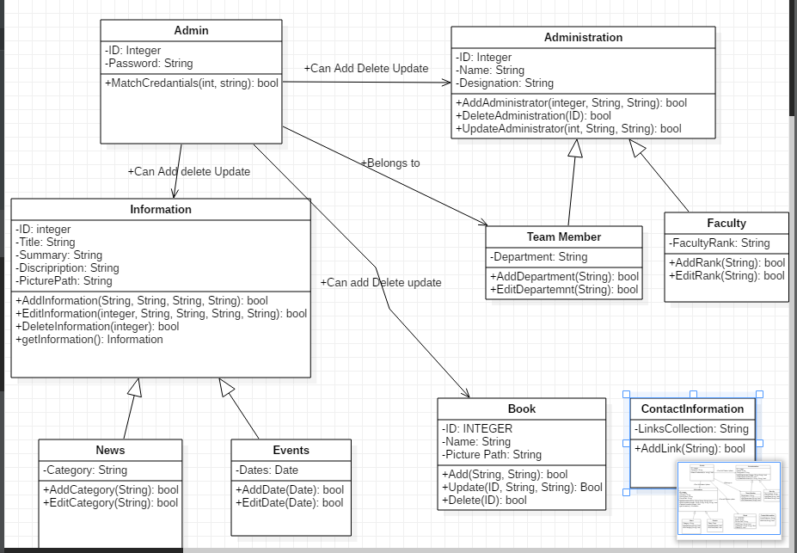

**ER Diagram**

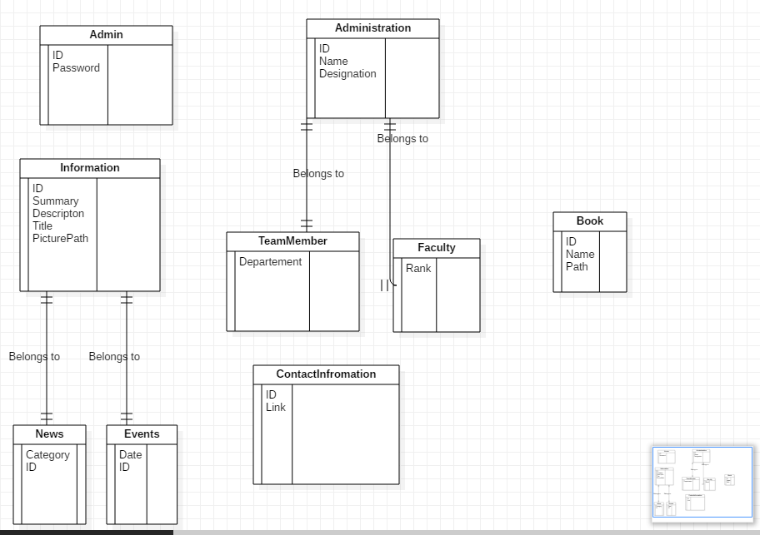

**Data flow Diagram**  
  
  
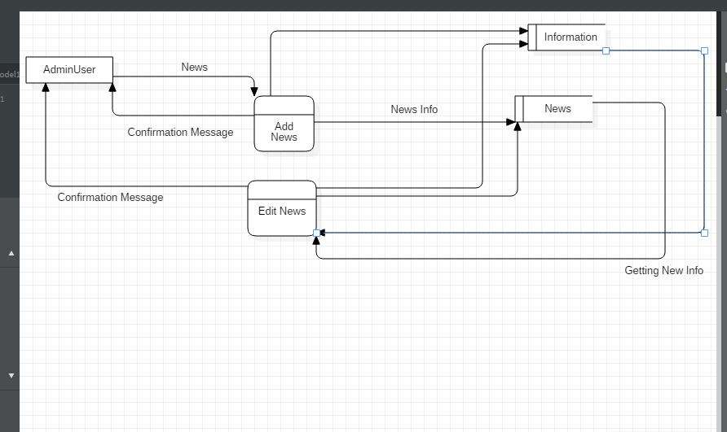  
  
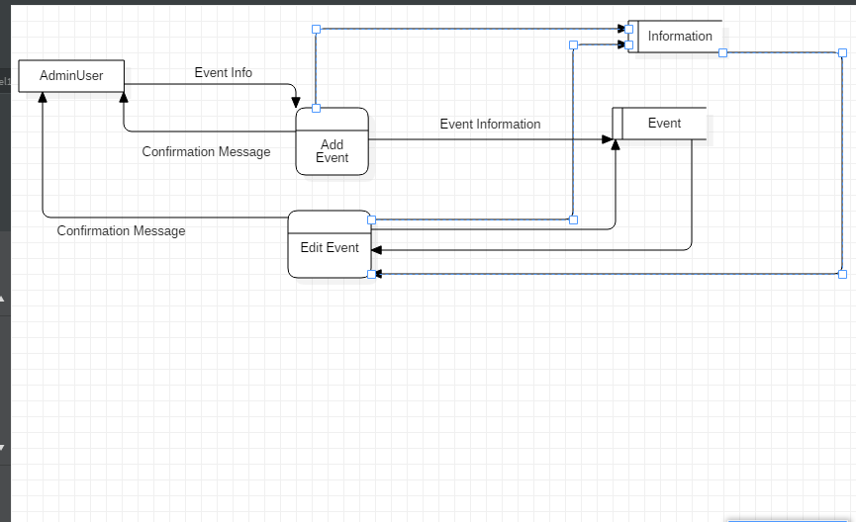  
  
  
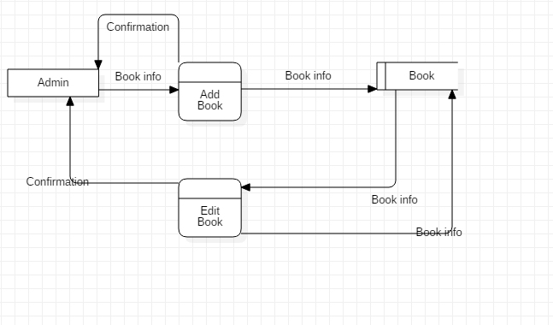  
  
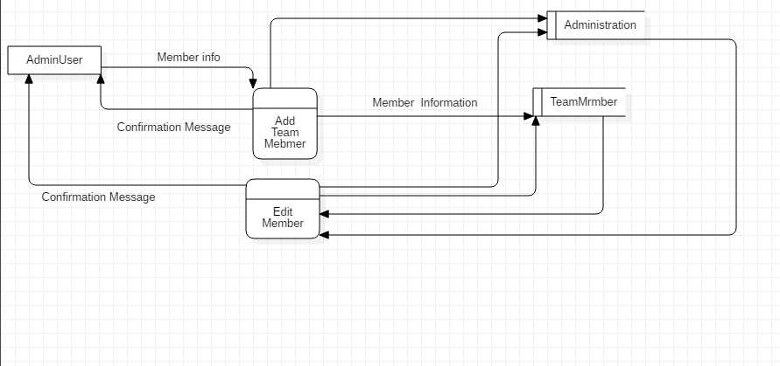  
  
  
  
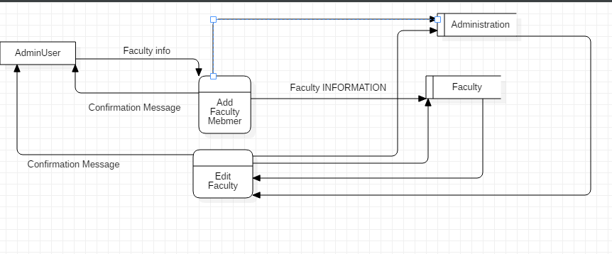

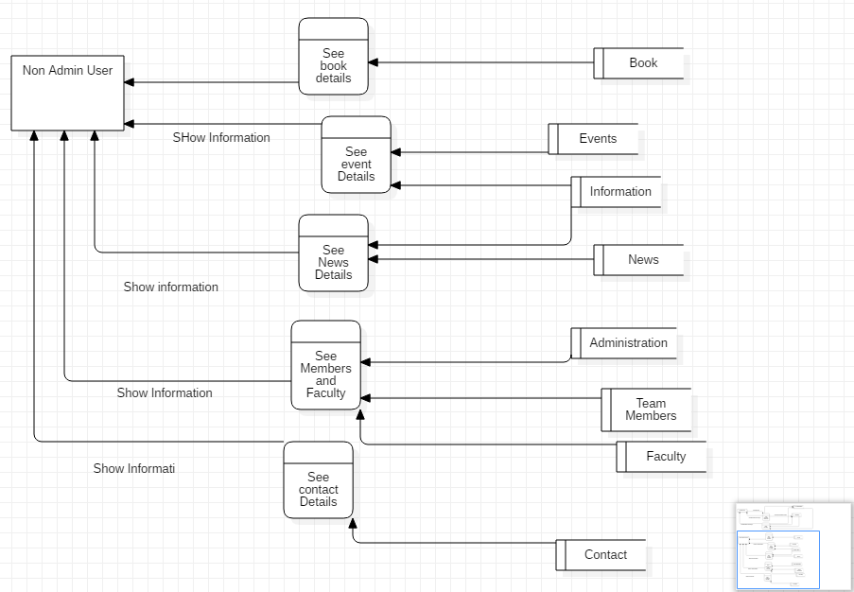

**Use Case Diagram**  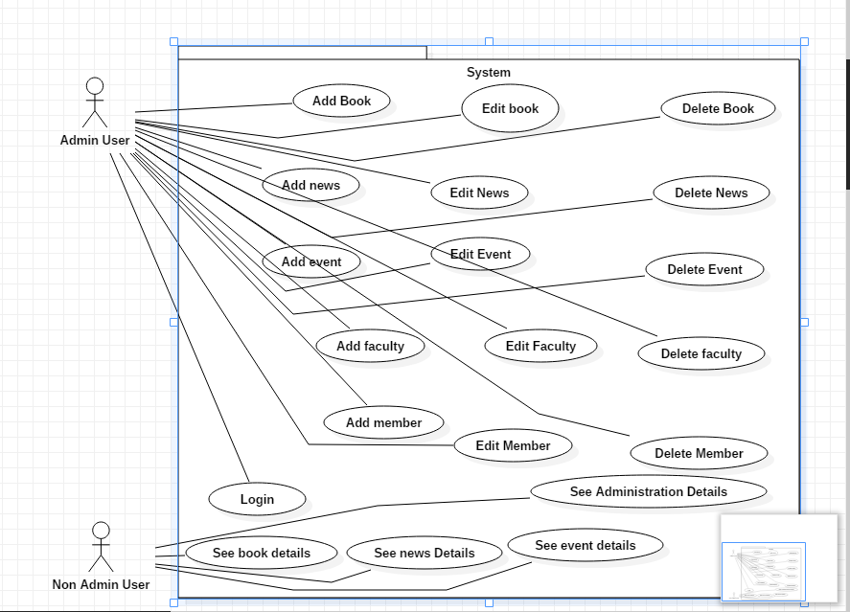

Appendix C: Design Models

*< Include the following design model: component diagram.>*

Appendix D: Screenshots

*< Include all screenshots of your software application’s graphical user interface.>*

Appendix E: Test Cases

· < Fill out the following template for each test case.>

·

|  |  |
| --- | --- |
| **Identifier** | TC-1 |
| **Priority** | <Choose one from {High, Medium, Low}> |
| **Related requirements(s)** | <Include use-case identifier(s) for functional requirement(s) and SRS section/sub-section number(s) for other requirement(s).> |
| **Short description** | … |
| **Pre-condition(s)** | … |
| **Input data** | … |
| **Detailed steps** | … |
| **Expected result(s)** | … |
| **Post-condition(s)** | … |

Table 2: TC-1

Appendix F: IV & V Report

**IV & V Resource**

Name Roll # Signature

·

|  |  |  |  |  |  |
| --- | --- | --- | --- | --- | --- |
| **S#** | **Defect Description** | **Origin Stage** | **Status** | **Fix Time** | |
| **Hours** | **Minutes** |
| 1 |  |  |  |  |  |
| 2 |  |  |  |  |  |
| 3 |  |  |  |  |  |
| … |  |  |  |  |  |

**Table 3: List of non-trivial defects**

Appendix G: Risk Report

**[1]Project Risks**

|  |  |  |  |  |  |
| --- | --- | --- | --- | --- | --- |
| **Risk Description** | **Impact**  **(1 – 10)** | **Probability**  **(0 – 1)** | **[2]Risk**  **Exposure** | **Weeks Active** | **Mitigation Strategy** |
|  |  |  |  |  |  |
|  |  |  |  |  |  |
|  |  |  |  |  |  |
|  |  |  |  |  |  |
|  |  |  |  |  |  |

·

Appendix H: Activity Timesheet

|  |  |  |
| --- | --- | --- |
| **Activity** | **Time** | |
| **Hours** | **Minutes** |
| Requirements Engineering |  |  |
| Analysis and Design |  |  |
| Implementation |  |  |
| Testing |  |  |
| Deployment |  |  |
| Project Management |  |  |
| IV & V |  |  |

**Project Manager**

Name Roll # Signature

·

Appendix I: Updated Project Plan

· < Include screenshots of your updated project plan prepared using MS Project.>

·

[1] Risks should be sorted in descending order of risk exposure.

[2] Risk Exposure = Risk Impact x Risk Probability